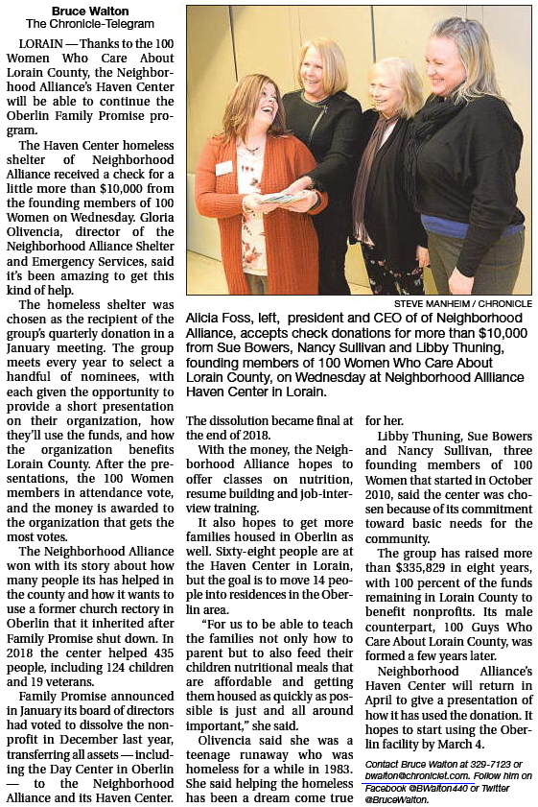

**Haven Center Receives $10K from 100 Women**